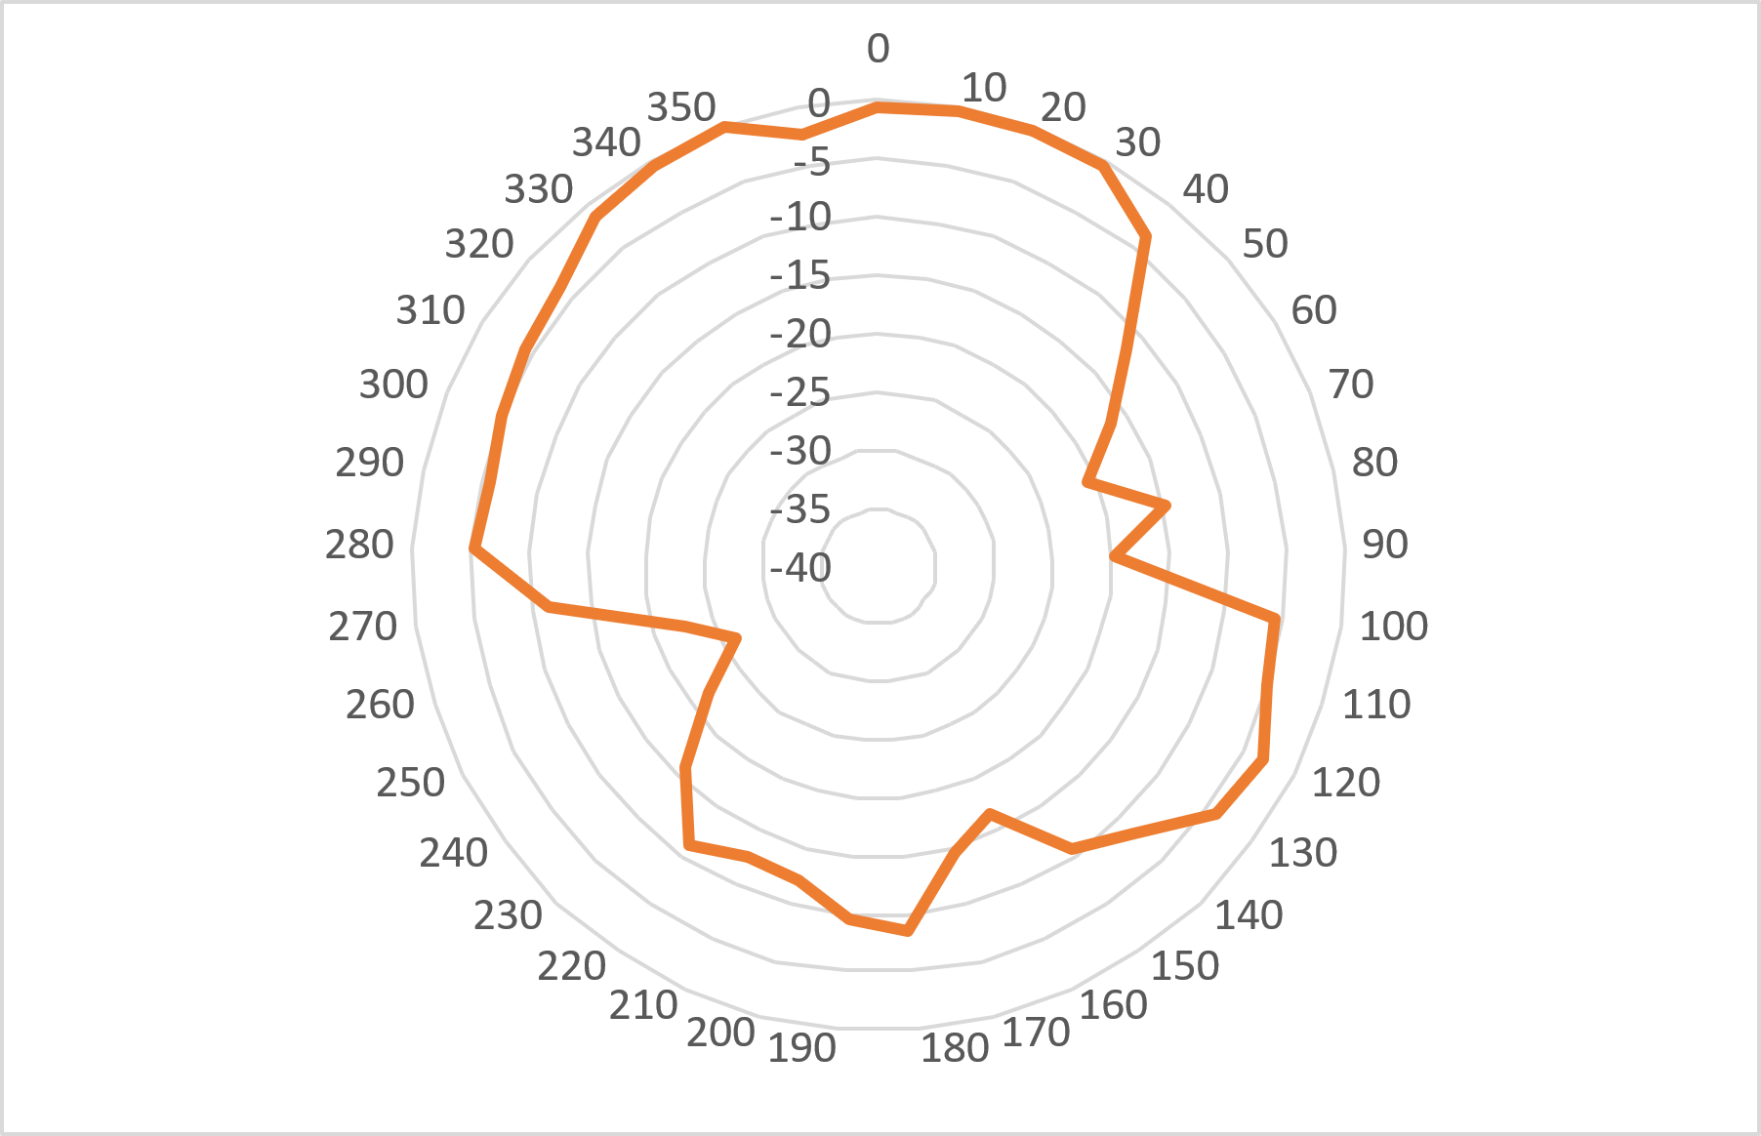
HPBW = 360° – 320°
= 40° + 40°
= 80°

B = 160°
F = 350°

B = 180°
F = 350°
HPBW = 360° – 330°
= 30°

